LESSON PLAN VII

Subject: Christmas shopping!! Time: 45 min Level: 6th Grade, Primary School

Aims of the lesson:
- to review and learn Christmas vocabulary
- to learn Christmas customs and traditions
- to practise reading skills
- to get used to technological devices and Apps in the process of learning English
- to develop the ability of using QR codes

Techniques and methods of work:
- brainstorming
- programming method (reading QR codes)
- communicative method
- practice method
- playing interactive language games

Assumed knowledge:
- Students know Christmas vovabulary
- Students know Christmas customs and traditions
- Students can use QR codes

STAGE | ACTIVITY | OBJECTIVES | INTER-  ACTION  PATTERN | TIME | MATERIALS
Warm - up | T introduces the topic of the lesson.  T explains what are QR codes and checks if every S has got a QR code scanner installed on the tablet or the smartphone. T distributes a QR code to each S. Ss scan the code and their task is to search the words related to Christmas enumerated on the right. | encouraging Ss to take part in the lesson | T → Ss  Ss → T  individual work | 6 min | tablets or smartphones  QR code
Presentation | T divides Ss into pairs. Each pair receives a handout with two tasks to do. Ss are supposed to match the words on the left with the meanings on the right. T checks Ss’ answers. I necessary, T gives some tips to help Ss guess the meaning of new words. | presenting new vocabulary | pair work  T → Ss  Ss → T | 5 min | T’s handout  Appendix 1
Controlled  Practice | Then, Ss use the presented words to complete the sentences. | drilling,  practising new words | pair work  T → Ss  Ss → T | 4 min | T’s handout  Appendix 1
Controlled Practice | T presents a text on the screen. The text is about a special Christmas gift and it contains some gaps. T points to Ss who read some parts of the text and fill in the gaps with the correct word.  Next, T asks individual Ss to scan the presented codes. The selected Ss read 6 questions to the text and try to give the correct answers. | drilling, practising new vocabulary | T → Ss  Ss → T  S →Ss / T | 5 min  4 min | a laptop,  a projector and a screen  Appendix 2  Appendix 3
Controlled Practice | T asks Ss about the Christmas traditions and customs in Poland and other countries they know.  Then, T divides Ss into groups. Each group receives a handout with 6 T/F statements. Ss need to mark 3 correct sentences (1,3,5 are T) and then, colour the squares with the numbers corresponding with the correct answers. T monitors the class and helps Ss in case of any problems. | activating Ss  getting Ss involved into the lesson and motivating them | T → Ss  Ss → T  group work | 4 min  8 min | T’s handout  Appendix 4
Production | When they finish, Ss scan the code they have created and do the hidden task. After scanning the correct code, Ss play an interactive Christmas game called Millionaire individually. The first person from each group who answers all the questions correctly can get an extra bonus from T . | practising new vocabulary and Christmas customs | individual work | 6 min | tablets or smartphones  the correct QR code  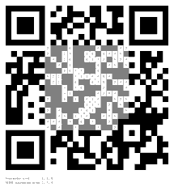
Homework | T sets the homework. Ss get a QR code to scan at home. Ss’ taks is to listen to the Christmas song All I want for Christmas and do a multiple choice quiz. |  | T → Ss | 3 min | tablets or smartphones  QR code  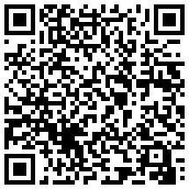

Appendix 1

CHRISTMAS SHOPPING
A Special Christmas Gift
Vocabulary Practice

l Match the words on the left with the meanings on the right.
- bracelet B A. a small plastic card used to buy things
- cash B. jewellery that you wear on your wrist
- cashier C. a covering for your hands
- check-out counter D. used to say that something bad has happened
- credit card E. money in the form of coins and bills
- gloves F. the place in a store where the cashier works
- sweater G. a warm piece of clothing worn on your upper body
- unfortunately H. a person who works at a store by taking money

l Use the above words to complete the sentences.

- My hands don’t feel cold because I am wearing _________________.
- Sam forgot to bring his money, but it’s okay. He has a _________________.
- I did my homework. _________________, I forgot to bring it to school!
- I want to buy this book. Where is the _________________?
- My friend found a new job. He works as _________________ in a supermarket.
- I always wear a _________________ and a jacket when it gets cold.
- Would you like to pay by _________________ or credit?
- Kelly likes jewellery. She’s wearing a ring and a _________________.

Appendix 2

l Complete the text with the words above.

A Special Christmas Gift

cashier n. bracelet n. cash n. check-out counter n. colour n. credit card n. gloves n.
shopping mall n. size n. sweater n.

I will never forget a very special gift that I got last year. It was a few days before Christmas on a cold, weekend morning and outside everything was covered in a beautiful blanket of snow. I decided to go Christmas gift shopping for my family and friends, so I put on some warm clothes and took a bus to West Edmonton Mall, the largest (1) shopping mall in Canada.

After I got there, I found a nice, warm (2)____________ for my father. It was blue, his favorite (3) _____________. I also found a beautiful pair of (4)_____________ for my mother. I knew they were the right (5) _____________ because her hands are the same size as mine. In addition, I got some toys for my younger sister and brother, and a (6) _____________ for my friend. Finally, after three hours, I took everything and waited in line at the (7) _____________ to pay for it. Can you guess what happened next? I didn’t have enough (8) ____________ to pay for it all! I still needed another ten dollars to give to the (9) _____________, and unfortunately I didn’t have my (10) _____________ with me. I didn’t know what to do! That’s when a very kind lady behind me gave me a very special Christmas gift. She smiled at me … and then gave me the ten dollars I still needed to pay for everything!
Appendix 3

Question 1 Question 2 Question 3 Question 4 Question 5 Question 6
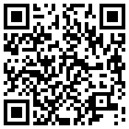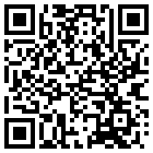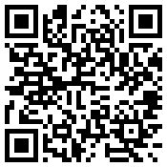

Appendix 4

Find three correct answers. Then, colour the squares with the numbers corresponding with the correct answers. When you finish, scan the code and do the task.

- 24th December is called CHRISTMAS EVE. T / F
- Santa Claus travels by plane. T / F
- English people traditionally eat turkey on Christmas Day. T / F
- In Great Britain people never decorate a Christmas tree. T / F
- British children hang a stocking by the fireplace to get presents from Santa. T / F
- Inside crackers there is some food. T / F
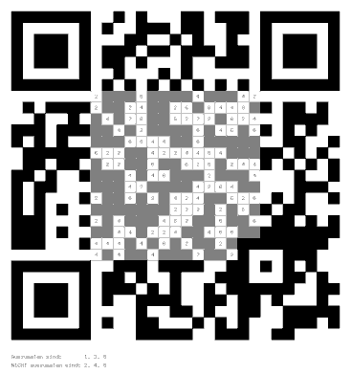
the correct QR code

