School things
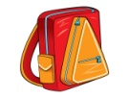
My name´s _______________. I´ve got (počet rokov) _________.
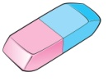
This is my school ___________. It´s ________________.
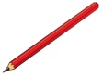
This is my ___________. It´s ________________.
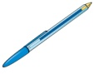
This is my ___________. It´s ________________.
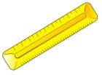
This is my ___________. It´s ________________.
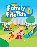
This is my ___________. It´s ________________.
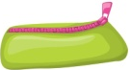
This is my ___________. It´s ________________.
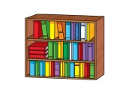
This is my ___________ case. It´s _______________.
_____________________

