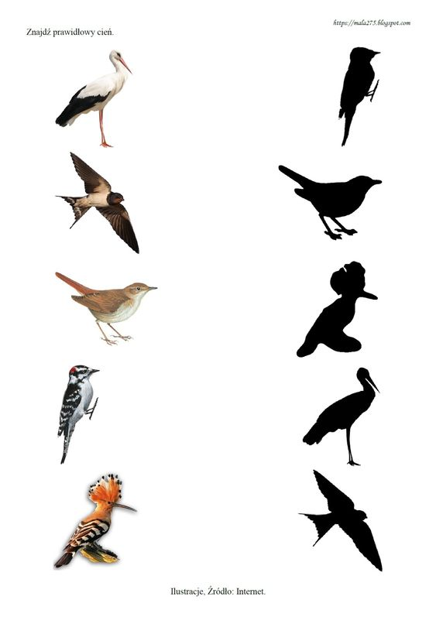https://pl.pinterest.com/pin/844493669001032/

